Project: Message to Parents to promote the Mayor’s Walk and Wheel Challenge 2024

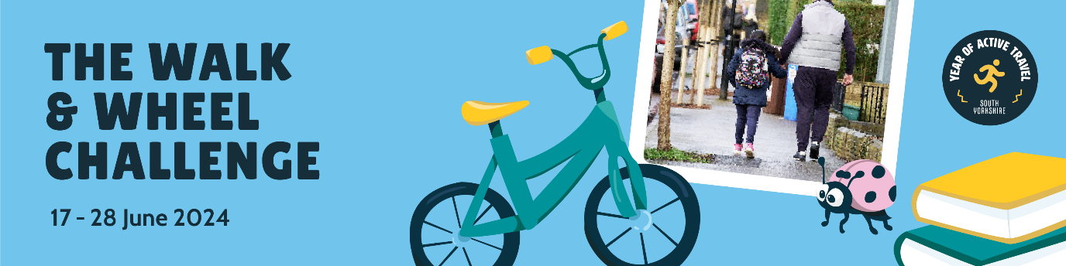

The Walk and Wheel Challenge – 17 – 28 June 2024

As part of our Year of Active Travel, the South Yorkshire Mayoral Combined Authority (SYMCA) is launching a brilliant new schools’ initiative across the region in June 2024 – The Walk and Wheel Challenge.

And we’re asking every parent and guardian to support the programme.

Between the 17th of June and the 28th of June 2024 (10 school days in total) we’d like every primary aged child in the region to choose Active Travel as their way of getting to and from school each day. Active Travel means walking, wheeling or cycling to school, and leaving the car at home.

Choosing Active Travel contributes to better physical health and mental well-being for everybody who uses it. Asking children to use it from a young age encourages them to automatically think about Active Travel in the future, when jumping in the car may have seemed the obvious option. The more of us who choose Active Travel will also help contribute to better environments, safer roads and cleaner air.

We’re delivering a complete activity programme to schools for the two weeks of the challenge, so kids learn all about how Active Travel can make the journey to school that bit more fun.

There will also be a prize draw for schools who have participated and thrown themselves into the spirit of the whole exercise.

We’d love your support in helping your children choose an Active Travel trip to school every day of the programme.

We’ll see you out there!

